GARDENING
Bird-scaping
By Sally Cunningham
http://www.buffalospree.com/buffalospreemagazine/archives/2010_04/0410gardening.html
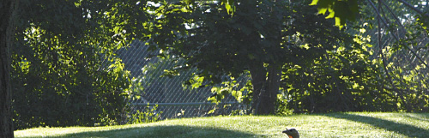
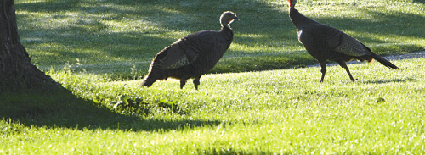

Photo by kc kratt.
Enlightened gardeners and homeowners often ask for native plants these days. Some choose natives because they know natural habitat is disappearing rapidly, and it’s our responsibility to replace what we can. Others just believe that indigenous plants are easier. (For the case for natives, see Buffalo Spree, June 2009.) People who don’t buy either of those arguments often desire our native beauties just because they attract birds. It’s hard not to love a cardinal.
Still, it’s not enough to sprinkle an American beech or lonely serviceberry here and there across a sea of mowed grass and expect great rewards from choosing native plants. It’s how we put them together that counts, and it’s all about layering.
Mother Nature’s design
When you walk in undisturbed woods and fields, it’s apparent that plants live in communities. Tall trees are flanked by smaller trees, with a middle layer of shrubs and then ground-covering grasses, perennials, and mosses. No one kind of plant predominates; nature doesn’t do “monocultures.” (If you’re not seeing this arrangement on your hikes, the problem is that most woods and fields are not natural any more, but are full of invasive, non-native plants—many of them in broad swaths forming monocultures. Unbalanced populations of animals, mainly deer, have eaten up the understory shrubs.) To simulate nature’s look, to re-create habitat, and to meet the needs of birds and other wildlife, we need to design or rearrange our home landscapes by planting in diverse plant groups with many layers.
From a wildlife point of view, the benefits of layering are obvious. The more diverse the planting levels, the more animals that can hide, breed, and dine in them. Birders find the most species among the several plant layers at woodland edges. Wild turkeys, woodcocks, grouse, and ovenbirds scratch up the ground to find seeds, insects, or worms. Eastern cardinals and many other birds nest in middle-story shrubs, while a vast variety seek the berries from summer well into winter. The top layer is the tree canopy, where warblers dine and many species sleep or escape predators.
Throughout all the layers other life forms benefit from the clustering of plants, insects the most important of all. While insects aren’t popular with most people, our culture needs to get past that and learn to think of them as dinner for birds. Insects are the essential food group that makes most higher forms of life possible. In any layered landscape, hundreds of insect species find what they need to survive: nectar and pollen from flowers, leaves or other insects to eat, tree trunks and ground litter for breeding or shelter, and moisture under the leaves.
The plants you choose to use in a layering scheme influence which birds and other animals visit or dwell in your yard. Native plants are first, usually best, choices. Along with flowering and berrying plants, include some evergreens. They are a requirement for bird nesting and winter protection, and you’ll appreciate their winter beauty. Finally, the most important rule is: Choose diversity at every level.
Layered clusters for your yard
After you analyze your site, make a wish list of trees and shrubs of various heights that at maturity will suit the soil, microclimate, and other conditions of your yard. Plan for big plants first, and the perennials, grasses, or groundcovers will be easy to plan and place later. For every tree, choose at least three different understory shrubs, and call them a cluster. For a large tree, use several of each shrub; for a small tree, fewer. Space all plants far enough apart to let them grow to full maturity without overrunning each other, but close enough to touch. (Be sure you put shrubs where they’ll get the amount of sun they need, once the limbs reach out.) Native understory shrubs are good at living in partial shade beside trees, and many will spread to find light or water as their partner tree matures.
If you can create only one small cluster or island, choose evergreens for part of the understory, or select a single evergreen as your upper layer. Ideally, your yard will permit more than one grouping. In that case, tie the design together by repeating some of the plants, or echo their shapes or colors.
If you already have too many large trees (the bane of many urban gardeners) you’ll have difficulty layering shrubs around them. Poke in the soil around the dripline to find where you can dig wide holes at least eighteen inches deep. Cut a couple of tree roots if you must. Plant the shrubs with lots of compost and water well through the season.
Establishing layers—for a bird hideout and dining hall—is well worth the effort.
A layered cluster for a moist site:
Tallest tree: Betula nigra (river birch)
Smaller tree(s): Malus coronaria or other crabapple cultivars with small fruits
Medium/tall shrubs: Amelanchier (serviceberry), Cornus sericea (red osier dogwood), Ilex verticillata (common winterberry; plant male and female.)
Short shrubs: Aronia arbutifolia (red chokeberry), Cephalanthus occidentalis (buttonbush)
Perennials: Aruncus dioicus (goatsbeard), Asclepias incarnata (swamp milkweed), Chelone glabra (turtlehead), ferns
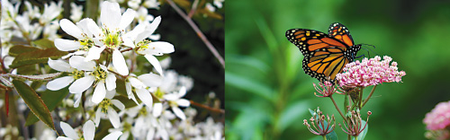

A layered cluster for a medium to dry site:
Tallest trees: Quercus rubra (red oak), Liquidambar styraciflua (sweetgum), Picea glauca (white spruce), Pinus strobus (eastern white pine)
Smaller tree(s): Crataegus phaenopyrum (Washington hawthorn), Chionanthus virginicus (white fringetree), Juniperus virginiana (eastern red cedar)
Medium/tall shrubs: Sambucus spp. (Elderberries) Myrica pensylvanica (bayberry; plant male and female), Viburnum spp. (many resistant to the viburnum leaf beetle)
Short shrubs: Clethra alnifolia (summersweet), Vaccinium angustifolium (lowbush blueberry)
Perennials: Asclepias tuberosa (butterfly weed), Asters, Baptisia australis (wild indigo), Veronicastrum virginicum (Culver’s root)
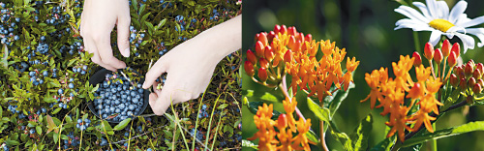

Sally Cunningham (CNLP) is author of Great Garden Companions (Rodale Books], and contributor to New Encyclopedia of Organic Gardening and others, as well as a lecturer, Buffalo News columnist, Channel 4 (WIVB-TV) Garden Expert, and consultant for Lockwood’s Greenhouses (Hamburg).

