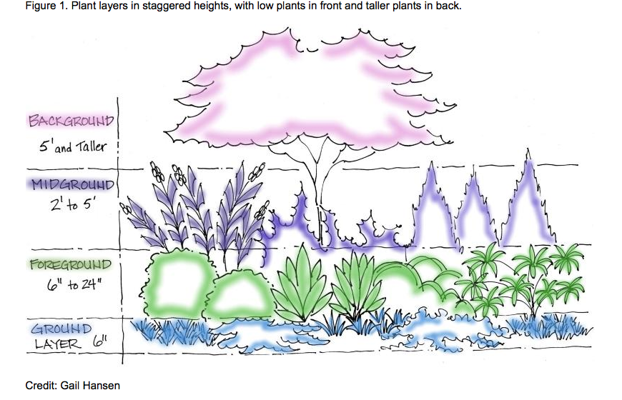

http://edis.ifas.ufl.edu/LyraEDISServlet?command=getImageDetail&image_soid=FIGURE%201&document_soid=EP449&document_version=1

